# Porchester Junior School

## Teaching Sequence for Writing

The Teaching Sequence for Writing compromises of the 6 key stages of process of writing. It allows coverage of essential skills needed to successfully write for purpose. Time is given to ensure quality and full understanding of the intended outcome.

The sequence is made up of the following key steps:

* IMMERSE
* ANALYSE
* SKILL
* PLAN
* WRITE
* REVIEW

**IMMERSE**

Immersion is the first part of the Teaching Sequence for Writing, in which the outcome is for children to develop **new vocabulary** and understand the **purpose** for writing. In this stage, children explore the context of the writing and acquire the necessary background knowledge needed in order to write successfully. This is where we separate the WHAT to write from the HOW to write. To do this, we must fully immerse our children in **vocabulary**, **facts**, **images** and **experiences** for them to feel they have the **background knowledge** to succeed. The teacher’s role is to give pupils the context for writing through exciting and stimulating activities that make our pupils want to write and explore.

The IMMERSION stage should involve the following types of activities:

* Vocabulary activities including levels of intensity, synonym work, graphic organisers etc
* Reading for research
* Drama and role play to develop vocabulary/empathy
* Visual literacy to bring the topic to life – videos, clips, music
* Small writing tasks to further embed the context of the end piece of writing

Immersive activities should involve some sort of response in books to ensure immersive experiences and vocabulary are committed to long term memory. These may include vocabulary lists, grouping vocabulary, synonym lists, role on the wall, labelled diagrams, vocabulary rich sentences, short paragraphs recounting experiences or annotated photos.

We must also give the pupils as many opportunities to TALK the context for writing. Oral rehearsal is vital for successful writing. If we expect our children to use adventurous Tier 2 vocabulary, we must immerse our children in it and give them as many opportunities to say improved vocabulary aloud.

At this stage, teachers will **pre-plan an immersive list of ambitious vocabulary** and teach children how to use this effectively in the context. Providing children with rich vocabulary and allowing them to use it through activities such as role play, will give the children the opportunity to hear themselves saying it in the correct context, which in turn will improve the children’s confidence of using that word – therefore meaning it can be fed through into writing.

**ANALYSE**

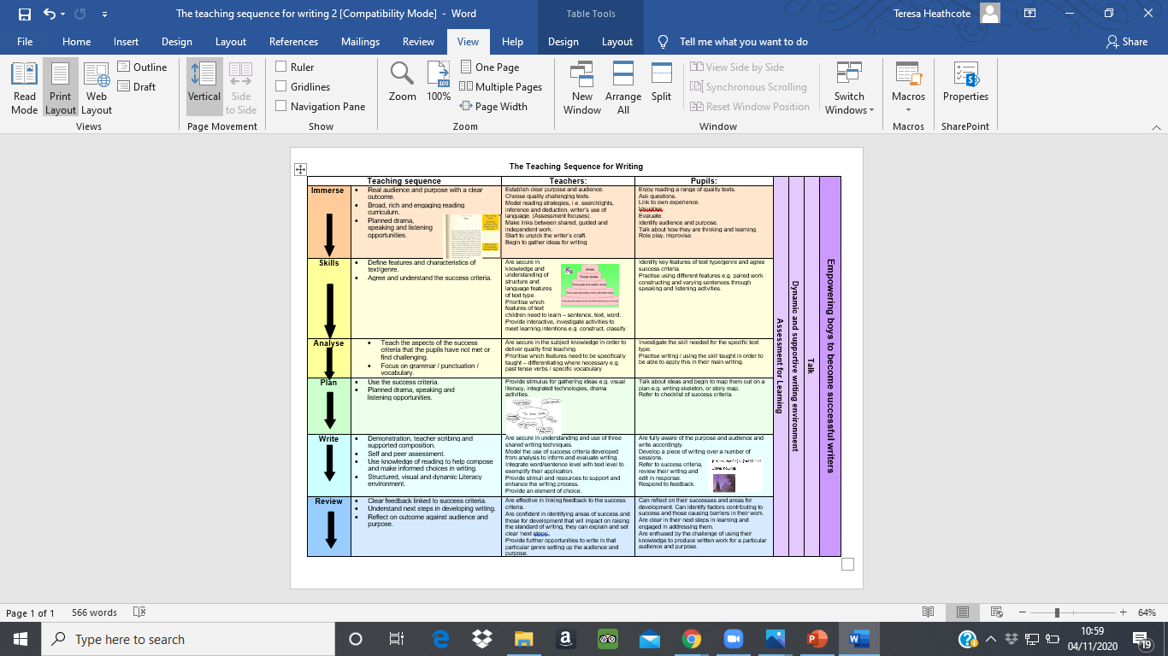

*ANALYSE could come before or after SKILLS depending on children’s familiarity with text type*

The National Curriculum states that children must ‘evaluate writing similar to that which they are going to write’ NC 2014. The ANALYSE section of the sequence allows children to become exposed to WAGOLLS of the **same context and purpose** and to deconstruct the WAGOLLS to be able to fully appreciate the **different features of this text type**.

During the session, pupils will look at both the **SPAG features** of a specific text type but also the **purpose and audience** within the text. Looking closely and language, phrases and specific **authorial intent**. Questions such as:

* Why has the author included this here?
* What does the author want the reader to think or feel when he writes…?
* What impact does this statement have on you?
* How does this description make the reader feel?
* What are they implying by writing…?

By children having the opportunity to explore in this way further embeds the purpose of the piece of writing and how we relay that purpose to the reader. If we want the reader to feel scared – which elements in the WAGOLL show that the author wanted the reader to feel like that?

It is here that the pupils identify the SUCCESS CRITERIA for the next phase of the Teaching Sequence for Writing.

### WAGOLLS

* Context and structure should be equal when analysing a WAGOLL.
* The WAGOLL illustrates the end goal of the writing and should be referred to throughout the teaching sequence.
* Success criteria should be created with the pupils.
* WAGOLLS on learning walls should be easily visible – perhaps only display the first part, large enough to see.
* Pupils’ writing outcomes make the good WAGOLLs for future years.

**SKILLS (SPAG)**



The SKILL section of the sequence should be taught in the context of the writing. What elements of SPAG are needed to successfully write this text type/piece of writing? If we are writing a basic non-chronological report, we should not be teaching inverted commas for direct speech as this is not a feature of this text type.

All SKILL sessions will **link to the context** of the writing. These sessions will teach the core skills of the SPAG (taken from KKPDs and TAFs) and will then allow children the opportunity to use it in context. Emphasis should be given to the effect the grammar has on the writing. The following should be considered:

Within the SKILL section of the Teaching Sequence for Writing, there will be a stand-alone **spelling session** which will link directly the vocabulary created during the IMMERSION section. There is an expectation that these words will never be spelt incorrectly during the children’s writing as they are always visibly available and constantly referred to on the learning wall. This spelling session will include an opportunity to delve into spelling rules/patterns/language structure and contain the following elements:

* Explore the tricky elements and pitfalls associated with each spelling.
* Spelling games (quick write, hangman, circle spelling, look cover write check).
* Low stakes testing (on whiteboard) – pupils take notice of the words incorrectly spelled.

**PLAN**



The purpose of planning is to allow learners to **organise** and **sequence** their writing. It is crucial that as our children become more confident and free writers, we give them the opportunity to plan in different ways. Planning is dependent upon the text type. We wouldn’t plan a story in the same was we would a letter - one planning format does not fit all. We must expose and teach our children a range of effective planning formats so they can choose which feels most comfortable to them. Teachers will model planning to the children, verbally talking aloud about what they are doing and why.

During this stage of the sequence, we will teach children that planning is **note taking** and the impact of this. We will teach children that planning is **talking** and **rehearsing** what we want to say and when we need to say it. Collaborative planning is one of the single most effective strategies for our children. Sharing and building on each other’s ideas and structures allows our less confident writers to feel involved and verbally participate.

**WRITE**



If the previous stages of the sequence have been followed and delivered effectively, pupils should be ready and well equipped for this stage. They should have the vocabulary, language and background knowledge to apply. They will have the understanding of the specific text type and have WAGOLLS to refer to. They will know which SPAG elements are effective and how to use them for effect and will have a detailed plan as to write from.

Within the WRITE stage of the sequence, **modelling** is key. Teachers will effectively model to pupils how to write from a plan. Modelling should take place in a variety of forms and good writing lessons incorporate all three of the following techniques in order to meet the needs of all learners.

### Modelled Writing

'Modelled Writing' is a specific strategy which allows the teacher to explicitly demonstrate the process of writing by 'thinking aloud' as you record your thoughts, for example, planning what you intend to write, talking about directionality, choice of words or how to spell or locate words. This may just be a sentence or two but it is the perfect opportunity to model to children what we want them to explicitly articulate in their heads. This is the stage where we ‘stroke our learning wall’ – for example, take a word from the vocabulary section and go back to your board to use it. Children will see you using it and start to value it as a learning tool.

### Shared Writing

In shared writing, the students collaborate with the teacher to jointly construct a written text. After modelling the first sentences, it may be wise to open up the next sentence to the floor. The teacher acts as scribe, prompting, questioning and supporting the students as the text is shaped. Shared writing can be employed as a whole class or small group strategy. Shared writing is more enjoyable for the pupils as they feel involved, but it is not as effective as modelled writing and can sometimes become quite chaotic and not also create the desired outcome. Shared writing is more effective for developing and sharing/discussing ideas.

### Guided Writing

Once children have been allowed to write freely, this will give the teacher time to work closely with a small group of pupils to work together on ‘Guided Writing.’ Guided writing is a small group approach, involving the teacher meeting with a group of students with similar writing needs. The formation of the group, the focus and the time they spend together is based on the teacher's ongoing formative assessment processes.

Children will also be encouraged to take part in ‘slow writing’ during the first few sequences of the year. Slow Write isn’t the same as the previously known technique of giving children specific objectives or success criteria to meet. It is simply, writing slowly and encouraging children to take their time to think, say, write and read review. Children will write sentence by sentence following the steps:

* Think about your sentence
* Say your sentence
* Write your sentence
* Read your sentence
* Review your sentence

**REVIEW (EDIT)**

In some respects, reviewing should take place constantly from the planning stage onwards and children must be encouraged to re-read their writing for sense, making corrections constantly.

During this stage we must instil into our pupils that the first draft of a piece of writing is not the finished product. As writers, we must **read, review and edit** our writing to make it the best it can be. Children must be taught how many times published authors will edit and review their writing before a finished book is published. We must not ‘turn off’ our learners and make them reluctant, we must encourage them and foster an ethos that edited writing is the best writing.

The REVIEW stage can take many forms. We cannot expect our children to know how to edit and improve. Our children will be proud of the work they have produced and will have worked incredibly hard, therefore thinking it is already right. Teachers will teach pupils how to edit. They will model this processes and provide opportunities to develop children into reflective writers.

AFL strategies will be used to lead REVIEW sessions. Pieces of writing, containing errors taken straight from children’s work will be used for modelling purposes. Children will work collaboratively to find and make corrections to these, before being asked, ‘has anyone made a similar mistake in their writing – edit it now.’ This will empower children to know what to look for and how to make, without seeing this as a negative.

Within the REVIEW sessions, **content, composition, SPAG and spelling** will be focused on.

Once children have independently reviewed their writing, children should be allowed time to present the finished text as a **high-quality final piece** that they are proud of. Children will be taught how to look back and ensure corrections are included in their final write up and misconceptions/errors are not simply recopied. As through the whole sequence, but particularly at this point, handwriting will be a significant factor that will be prioritised and praised.